  Please join us!  Your local surgery has a Patient Participation Group  Gildersome Health Centre  Finkle Lane  LS27 7HL |  |  |  | 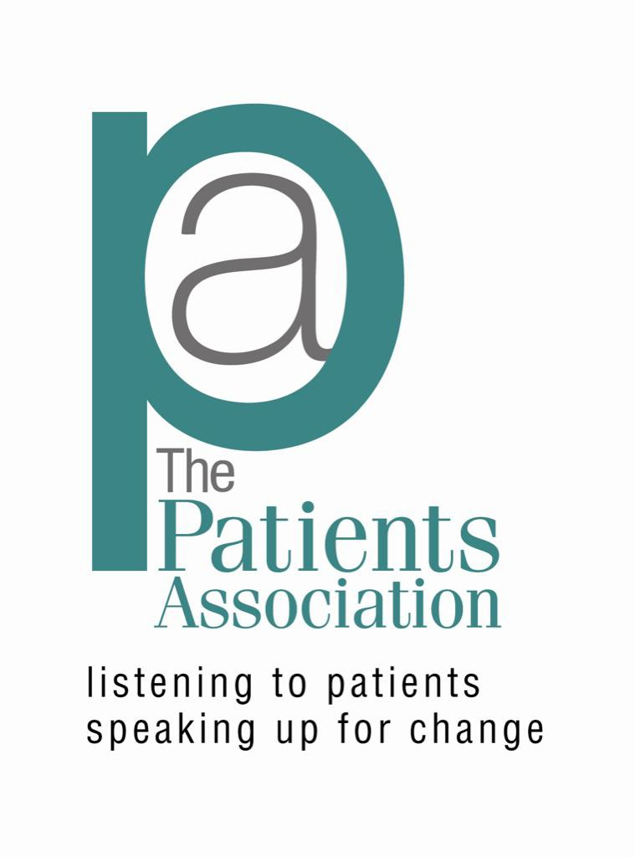
  What is the Patient Participation Group or PPG?
  A Patient Participation Group (PPG) is a group of people who are patients of the surgery and want to help it work as well as it can for patients, doctors and staff. The NHS requires every practice to have a PPG.
  Why should I join?
  You have been to the surgery as a patient, parent, carer or friend.
  Your experiences matter and you can bring different ideas to the surgery to help us treat patients better or to improve what we do in some way.
  You will also gain a better understanding of the NHS, and gather feedback from other patients.
  
  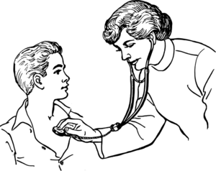
  The Patients Association
  We are a long established, independent advice and campaigning charity. We also undertake project work with health and social care organisations to ensure the patient voice is heard and improvements are made. We offer support and advice to individual patients/ forums and groups. Phone or email our helpline.
  Helpline: 0845 608 44 55
  Office: 0208 423 9111
  Email: helpline@patients-association.com
  You can also follow us on Twitter
  Twitter: @PatientsAssoc
  Sign up for our weekly newsletter via our website www.patients-association.org.uk

  How often does the Patient Participation Group meet?  We meet at the surgery, but not too often. We know that you are busy, so we meet only a few times per year and hope that you can join us.  If you can’t make meetings then don’t worry – you can still be part of our virtual group.  This leaflet was produced in partnership with  The Patients Association  Listening to Patients, Speaking up for Change |  |  | What is a virtual group?  A virtual group is a group of patients who would like to be part of the Patient Participation Group but prefer not to attend meetings. They get involved by email instead. Information such as practice newsletters, minutes of the Patient Participation Group meetings and surveys will be shared electronically. It means that if you can’t make face-to-face meetings, are caring for someone and unable to leave them, or are working, you can still be kept informed, give your views and participate.  Will my views be heard?  Your views are important and will be listened to. It may not be possible to act on every suggestion, but all feedback is very valuable.  Working in a spirit of mutual respect, openness and trust, all patients' views will be discussed and, where appropriate, we will work together on solutions. |  |  | Yes, please, I want to be part of the Patient Participation Group:  Name:  Address:  Telephone:  Email:  Please tear off this part of the leaflet and hand to your receptionist or email:

